SHENZHEN CHUANGTONG ELECTRONIC INSTRUMENTS CO.,LTD.

Declaration of Conformity UE

1. Massage equipment: Rebive Air (Model MT-RBA22W/ MT-RBA22B)

2. Name and address of the manufacturer or his authorised representative:
SHENZHEN CHUANGTONG ELECTRONIC INSTRUMENTS CO.,LTD.
1501, Shenzhen Luohu Investment Holding Building B,112 Qingshuihe 1st Road, Luohu District, Shenzhen. GuangDong. China

3. This declaration of conformity is issued under the sole responsibility of the manufacturer.

4. Object of the declaration:

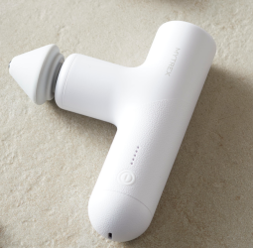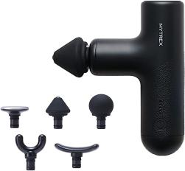
- Massager Gun with colors in black /white /Reference: MT-RBA22W/ MT-RBA22B

5. The subject matter of the declaration described above is in conformity with the relevant Union harmonisation legislations:
• EMC (2014/30/EU): Electromagnetic Compatibility Directive
• LVD (2014/35/EU): Low Voltage Directive
• RoHS (2011/65/EU): Restriction of the use of certain hazardous substances directive
- References to the relevant harmonised standards used or references to the other technical specifications in relation to which conformity is declared.

EN IEC 55014-1:2021: Electromagnetic compatibility - Requirements for household appliances, electric tools and similar apparatus - Part 1: Emission.

EN IEC 55014-2:2021: Electromagnetic compatibility - Requirements for household appliances, electric tools and similar apparatus - Part 2: Immunity

EN IEC 60335-1:2012 + A11:2014 + A13:2017 + A1:2019 + A2:2019 + A14:2019 + A15:2021: Household and similar electrical appliances - Safety - Part 1: General requirements + Amendment 11:2014 + Amendment 13:2017 + Amendment 1:2019 + Amendment 2:2019 + Amendment 14:2019 + Amendment 15:2021

EN IEC 60335-2-32:2021:Household and similar electrical appliances - Safety - Part 2-32: Particular requirements for massage appliances

EN IEC 62233:2008: Measurement methods for electromagnetic fields of household appliances and similar apparatus with regard to human exposure

IEC 62321-4:2013+AMD1:2017: Determination of certain substances in electrotechnical products. Part 4: Determination of mercury in polymers, metals and electronic components using CV-AAS, CV-AFS, ICP-OES and ICP-MS.

IEC 62321-7-1:2015: Determination of certain substances in electrotechnical products. Part 7-1: Determination of hexavalent chromium (Cr (VI)) in coloured and colourless corrosion protected coatings of metals by the colorimetric method.

IEC 62321-7-2:2017: Determination of certain substances in electrotechnical products. Part 7-2: Hexavalent chromium. Determination of hexavalent chromium (Cr (VI)) in polymers and electronic products by the colorimetric method.IEC 62321-6:2015

IEC 62321-8:2017: Determination of certain substances in electrotechnical products. Part 8: Phthalates in polymers by gas chromatography-mass spectrometry (GC-MS), pyrolysis/thermal desorption-gas chromatography-mass spectrometry (Py/TD-GC-MS).

7. Additional information:
Signed on behalf of SHENZHEN CHUANGTONG ELECTRONIC INSTRUMENTS CO.,LTD.:


City and date:
Shenzhen, 18th of March, 2025

Name and position:
Zhang Liang

CEO

